Questions:

* 1. Show all of the information on the Avengers.

a. Query: SELECT * FROM Avengers;

b. Columns: all? So many is hard to count them all.

c. Expected row count: 174

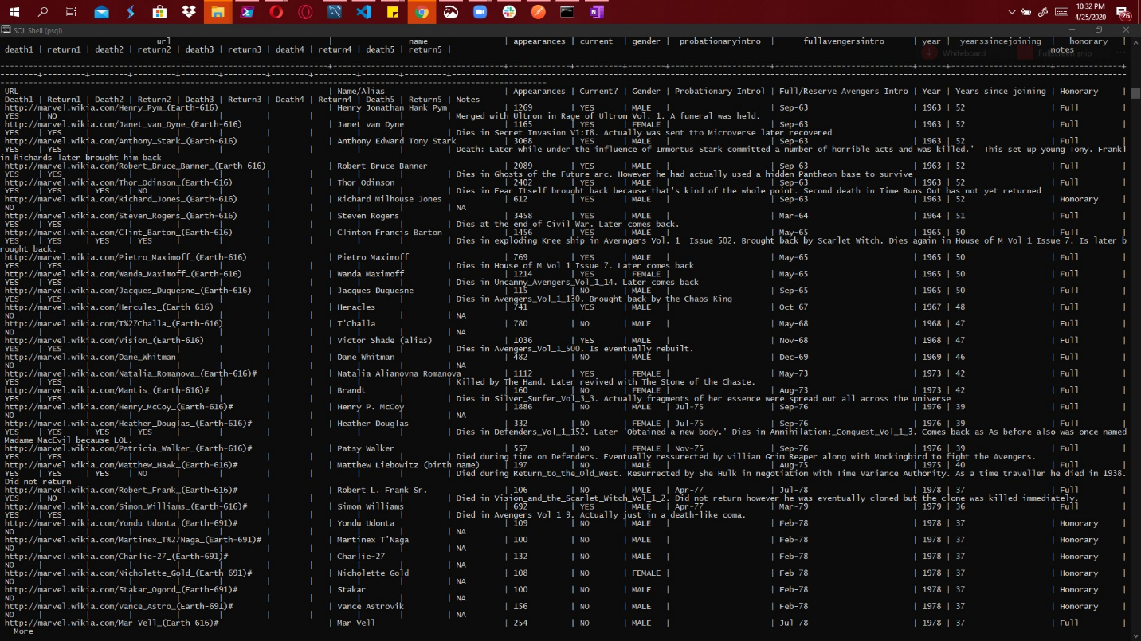

* 1. Create a new table with information from another super hero group [can be imported from elsewhere or fictitious]. Make sure there is an appropriate header and must be at least 30 rows.

a. Query:

-- ALTER TABLE "MoreHeroes" ADD id SERIAL PRIMARY KEY;

-- ALTER TABLE public."MoreHeroes"

-- ADD COLUMN name varchar;

-- ALTER TABLE public."MoreHeroes"

-- ADD COLUMN powerstats varchar;

-- ALTER TABLE public."MoreHeroes"

-- ADD COLUMN biography varchar;

-- ALTER TABLE public."MoreHeroes"

-- ADD COLUMN appearance varchar;

-- ALTER TABLE public."MoreHeroes"

-- ADD COLUMN work varchar;

-- ALTER TABLE public."MoreHeroes"

-- ADD COLUMN imageUrl varchar;

-- ran queries 1-15 rows twice to save time (since this is not for a real purpose)

-- INSERT INTO "MoreHeroes" (name, powerstats, biography, appearance, work, imageurl)

-- VALUES ( 'A-Bomb',

-- '{"intelligence":"38","strength":"100","speed":"17","durability":"80","power":"24","combat":"64"}',

-- '{"full-name":"Richard Milhouse Jones","alter-egos":"No alter egos found.","aliases":["Rick Jones"],"place-of-birth":"Scarsdale, Arizona","first-appearance":"Hulk Vol 2 #2 (April, 2008) (as A-Bomb)","publisher":"Marvel Comics","alignment":"good"}',

-- '{"gender":"Male","race":"Human","height":["203 cm"],"weight":["980 lb","441 kg"],"eye-color":"Yellow","hair-color":"No Hair"}',

-- '{"occupation":"Musician, adventurer, author; formerly talk show host","base":"-"}',

-- '{"url":"https://www.superherodb.com/pictures2/portraits/10/100/10060.jpg"}');

-- INSERT INTO "MoreHeroes" (name, powerstats, biography, appearance, work, imageurl)

-- VALUES ('Abe Sapien',

-- '{"intelligence":"88","strength":"28","speed":"35","durability":"65","power":"100","combat":"85"}',

-- '{"full-name":"Abraham Sapien","alter-egos":"No alter egos found.","aliases":["Langdon Everett Caul","Abraham Sapien","Langdon Caul"],"place-of-birth":"-","first-appearance":"Hellboy: Seed of Destruction (1993)","publisher":"Dark Horse Comics","alignment":"good"}',

-- '{"gender":"Male","race":"Icthyo Sapien","height":["191 cm"],"weight":["145 lb","65 kg"],"eye-color":"Blue","hair-color":"No Hair"}',

-- '{"occupation":"Paranormal Investigator","base":"-"}',

-- '{"url":"https://www.superherodb.com/pictures2/portraits/10/100/956.jpg"}');

-- INSERT INTO "MoreHeroes" (name, powerstats, biography, appearance, work, imageurl)

-- VALUES ('Abin Sur',

-- '{"intelligence":"50","strength":"90","speed":"53","durability":"64","power":"99","combat":"65"}',

-- '{"full-name":"","alter-egos":"No alter egos found.","aliases":["Lagzia"],"place-of-birth":"Ungara","first-appearance":"Showcase #22 (October, 1959)","publisher":"DC Comics","alignment":"good"}',

-- '{"gender":"Male","race":"Ungaran","height":["185 cm"],"weight":["200 lb","90 kg"],"eye-color":"Blue","hair-color":"No Hair"}',

-- '{"occupation":"Green Lantern, former history professor","base":"Oa"}',

-- '{"url":"https://www.superherodb.com/pictures2/portraits/10/100/1460.jpg"}' );

-- INSERT INTO "MoreHeroes" (name,powerstats, biography, appearance, work, imageurl)

-- VALUES ( 'Abomination',

-- '{"intelligence":"63","strength":"80","speed":"53","durability":"90","power":"62","combat":"95"}',

-- '{"full-name":"Emil Blonsky","alter-egos":"No alter egos found.","aliases":["Agent R-7","Ravager of Worlds"],"place-of-birth":"Zagreb, Yugoslavia","first-appearance":"Tales to Astonish #90","publisher":"Marvel Comics","alignment":"bad"}',

-- '{"gender":"Male","race":"Human / Radiation","height":["203 cm"],"weight":["980 lb","441 kg"],"eye-color":"Green","hair-color":"No Hair"}',

-- '{"occupation":"Ex-Spy","base":"Mobile"}',

-- '{"url":"https://www.superherodb.com/pictures2/portraits/10/100/1.jpg"}');

-- INSERT INTO "MoreHeroes" (name, powerstats,biography, appearance, work, imageurl)

-- VALUES ( 'Abraxas',

-- '{"intelligence":"88","strength":"63","speed":"83","durability":"100","power":"100","combat":"55"}',

-- '{"full-name":"Abraxas","alter-egos":"No alter egos found.","aliases":["-"],"place-of-birth":"Within Eternity","first-appearance":"Fantastic Four Annual #2001","publisher":"Marvel Comics","alignment":"bad"}',

-- '{"gender":"Male","race":"Cosmic Entity","height":["-","0 cm"],"weight":["- lb","0 kg"],"eye-color":"Blue","hair-color":"Black"}',

-- '{"occupation":"Dimensional destroyer","base":"-"}',

-- '{"url":"https://www.superherodb.com/pictures2/portraits/10/100/181.jpg"}' );

-- INSERT INTO "MoreHeroes" (name, powerstats, biography, appearance, work, imageurl)

-- VALUES ( 'Absorbing Man',

-- '{"intelligence":"38","strength":"80","speed":"25","durability":"100","power":"98","combat":"64"}',

-- '{"full-name":"Carl Creel","alter-egos":"No alter egos found.","aliases":["Greithoth","\\"Crusher\\" Creel","Rocky Davis","Dynamite Davis","Lightningbolt","Prisoner #24957"],"place-of-birth":"New York City, New York","first-appearance":"Daredevil #1 (April, 1964) (As Rocky Davis)","publisher":"Marvel Comics","alignment":"bad"}',

-- '{"gender":"Male","race":"Human","height":["193 cm"],"weight":["270 lb","122 kg"],"eye-color":"Blue","hair-color":"No Hair"}',

-- '{"occupation":"Professional criminal; former professional boxer","base":"-"}',

-- '{"url":"https://www.superherodb.com/pictures2/portraits/10/100/1448.jpg"}' );

-- INSERT INTO "MoreHeroes" (name, powerstats, biography, appearance, work, imageurl)

-- VALUES ( 'Adam Monroe',

-- '{"intelligence":"63","strength":"10","speed":"12","durability":"100","power":"100","combat":"64"}',

-- '{"full-name":"","alter-egos":"No alter egos found.","aliases":["Takezo Kensei","Richard Sanders"],"place-of-birth":"-","first-appearance":"Heroes S02E01 - Four Months Later...","publisher":"NBC - Heroes","alignment":"good"}',

-- '{"gender":"Male","race":"null","height":["-","0 cm"],"weight":["- lb","0 kg"],"eye-color":"Blue","hair-color":"Blond"}',

-- '{"occupation":"former samurai swordsman, former British mercenary commander, former soldier in the Confederate Army","base":"U.S.; formerly Diedenshausen, Germany; Milan, Italy; Paris, France; Japan; England; Atlanta, GA; Montreal, Canada"}',

-- '{"url":"https://www.superherodb.com/pictures2/portraits/10/100/1026.jpg"}' );

-- INSERT INTO "MoreHeroes" (name, powerstats, biography, appearance, work, imageurl)

-- VALUES ( 'Adam Strange',

-- '{"intelligence":"69","strength":"10","speed":"33","durability":"40","power":"37","combat":"50"}',

-- '{"full-name":"Adam Strange","alter-egos":"No alter egos found.","aliases":["Warrior of Two Worlds","Savior of Rann"],"place-of-birth":"Chicago, Illinois","first-appearance":"Outsiders #6 (April, 1986)","publisher":"DC Comics","alignment":"good"}',

-- '{"gender":"Male","race":"Human","height":["185 cm"],"weight":["195 lb","88 kg"],"eye-color":"Blue","hair-color":"Blond"}',

-- '{"occupation":"Adventurer, archaelogist, ambassador","base":"Rann, Alpha Centauri System"}',

-- '{"url":"https://www.superherodb.com/pictures2/portraits/10/100/626.jpg"}' );

-- INSERT INTO "MoreHeroes" (name, powerstats, biography, appearance, work, imageurl)

-- VALUES ( 'Agent 13',

-- '{"intelligence":"null","strength":"46","speed":"null","durability":"null","power":"null","combat":"null"}',

-- '{"full-name":"Sharon Carter","alter-egos":"Sharon Carter","aliases":["-"],"place-of-birth":"-","first-appearance":"Tales of Suspense #75","publisher":"Sharon Carter","alignment":"good"}',

-- '{"gender":"Female","race":"null","height":["173 cm"],"weight":["135 lb","61 kg"],"eye-color":"Blue","hair-color":"Blond"}',

-- '{"occupation":"Agent of SHIELD","base":"S.H.I.E.L.D. Headquarters, New York City"}',

-- '{"url":"https://www.superherodb.com/pictures2/portraits/10/100/167.jpg"}' );

-- INSERT INTO "MoreHeroes" (name, powerstats, biography, appearance, work, imageurl)

-- VALUES ( 'Agent Bob',

-- '{"intelligence":"10","strength":"8","speed":"13","durability":"5","power":"5","combat":"20"}',

-- '{"full-name":"Bob","alter-egos":"No alter egos found.","aliases":["Bob","agent of Hydra","Bob","agent of A.I.M"],"place-of-birth":"-","first-appearance":"Cable & Deadpool #38 (May, 2007)","publisher":"Marvel Comics","alignment":"good"}',

-- '{"gender":"Male","race":"Human","height":["178 cm"],"weight":["181 lb","81 kg"],"eye-color":"Brown","hair-color":"Brown"}',

-- '{"occupation":"Mercenary, janitor; former pirate, terrorist","base":"Mobile; formerly Manhattan, Hellcarrier"}',

-- '{"url":"https://www.superherodb.com/pictures2/portraits/10/100/10255.jpg"}' );

-- INSERT INTO "MoreHeroes" (name, powerstats, biography, appearance, work, imageurl)

-- VALUES ( 'Agent Zero',

-- '{"intelligence":"75","strength":"28","speed":"38","durability":"80","power":"72","combat":"95"}',

-- '{"full-name":"Christoph Nord","alter-egos":"No alter egos found.","aliases":["Maverick"],"place-of-birth":"Unrevealed location in former East Germany","first-appearance":"-","publisher":"Marvel Comics","alignment":"good"}',

-- '{"gender":"Male","race":"null","height":["191 cm"],"weight":["230 lb","104 kg"],"eye-color":"-","hair-color":"-"}',

-- '{"occupation":"Mercenary, former government operative, freedom fighter","base":"-"}',

-- '{"url":"https://www.superherodb.com/pictures2/portraits/10/100/396.jpg"}' );

-- INSERT INTO "MoreHeroes" (name, powerstats, biography, appearance, work, imageurl)

-- VALUES ( 'Air-Walker',

-- '{"intelligence":"50","strength":"85","speed":"100","durability":"85","power":"100","combat":"40"}',

-- '{"full-name":"Gabriel Lan","alter-egos":"No alter egos found.","aliases":["-"],"place-of-birth":"Xandar, a planet in the Tranta system, Andromeda galaxy","first-appearance":"Fantastic Four #120","publisher":"Marvel Comics","alignment":"bad"}',

-- '{"gender":"Male","race":"null","height":["188 cm"],"weight":["240 lb","108 kg"],"eye-color":"Blue","hair-color":"White"}',

-- '{"occupation":"Former starship captain, Herald of Galactus","base":"-"}',

-- '{"url":"https://www.superherodb.com/pictures2/portraits/10/100/1358.jpg"}');

-- INSERT INTO "MoreHeroes" (name, powerstats, biography, appearance, work, imageurl)

-- VALUES ( 'Ajax',

-- '{"intelligence":"56","strength":"48","speed":"35","durability":"80","power":"34","combat":"55"}',

-- '{"full-name":"Francis","alter-egos":"No alter egos found.","aliases":["\\"Frankie\\"","the A-Man","the Attending"],"place-of-birth":"-","first-appearance":"Deadpool #14 (March, 1998)","publisher":"Marvel Comics","alignment":"bad"}',

-- '{"gender":"Male","race":"Cyborg","height":["193 cm"],"weight":["200 lb","90 kg"],"eye-color":"Brown","hair-color":"Black"}',

-- '{"occupation":"-","base":"-"}',

-- '{"url":"https://www.superherodb.com/pictures2/portraits/10/100/10422.jpg"}' );

-- INSERT INTO "MoreHeroes" (name, powerstats, biography, appearance, work, imageurl)

-- VALUES ( 'Alan Scott',

-- '{"intelligence":"63","strength":"80","speed":"23","durability":"90","power":"100","combat":"32"}',

-- '{"full-name":"Alan Ladd Wellington Scott","alter-egos":"No alter egos found.","aliases":["Green Lantern","White King","Sentinal"],"place-of-birth":"Gotham City","first-appearance":"All-American Comics 16 (1940)","Green Lantern","White King","Sentinal"],"place-of-birth":"Gotham City","first-appearance":"All-American Comics 16 (1940)","publisher":"DC Comics","alignment":"good"}', '{"gender":"Male","race":"null","height":["180 cm"],"weight":["201 lb","90 kg"],"eye-color"r":"Blue","hair-color":"Blond"}',

-- '{"occupation":"-","base":"Gotham City and New York City; Formerly Capitol City"}',

-- '{"url":"https://www.superherodb.com/pictures2/portraits/10/100/698.jpg"}' );

-- INSERT INTO "MoreHeroes" (name, powerstats, biography, appearance, work, imageurl)

-- VALUES ( 'Alex Mercer',

-- '{"intelligence":"50","strength":"80","speed":"42","durability":"90","power":"100","combat":"50"}',

-- '{"full-name":"Alexander J. Mercer","alter-egos":"No alter egos found.","aliases":["Prototype","Zues","Blacklight"],"place-of-birth":"-","first-appearance":"-","publisher":"Wildstorm","alignment":"bad"}',

-- '{"gender":"Male","race":"Human","height":["-","0 cm"],"weight":["- lb","0 kg"],"eye-color":"-","hair-color":"-"}',

-- '{"occupation":"-","base":"-"}',

-- '{"url":"https://www.superherodb.com/pictures2/portraits/10/100/10398.jpg"}' );

b. Columns: 7

c. Expected row count: 30

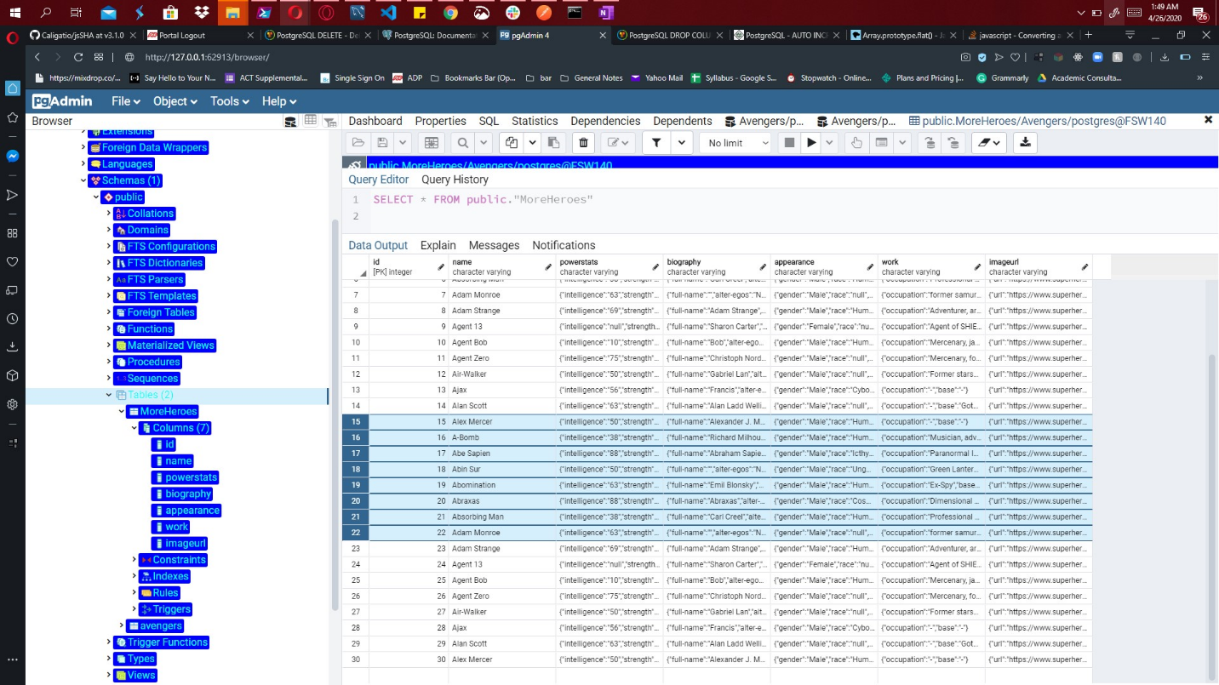

* 1. Add a column to your new table (the new superheros) for those who are interested in joining the Avengers. Make this be randomly assigned.

a. Query:

UPDATE "MoreHeroes"

SET wanttojoin = (random_between(0,1))

FUNCTION => {

CREATE OR REPLACE FUNCTION public.random_between(

low integer,

high integer)

RETURNS integer

LANGUAGE 'plpgsql'

AS $BODY$

BEGIN

RETURN floor(random()* (high-low + 1) + low);

END;

$BODY$;

ALTER FUNCTION public.random_between(integer, integer)

OWNER TO postgres;}

b. Columns: 8

c. Expected row count: 30

* 1. Add a column to your new table (the new superheros) for their favorite Avenger (have it randomly choose between Anthony Edward "Tony" Stark, Robert Bruce Banner, & Victor Shade).

a. Query:

UPDATE "MoreHeroes"

SET favorites = CASE WHEN random() < 0.4 then 'Anthony Edward "Tony" Stark' else CASE WHEN random() < 0.7 then 'Robert Bruce Banner' else 'Victor Shade' END END

b. Columns: 9

c. Expected row count: 30

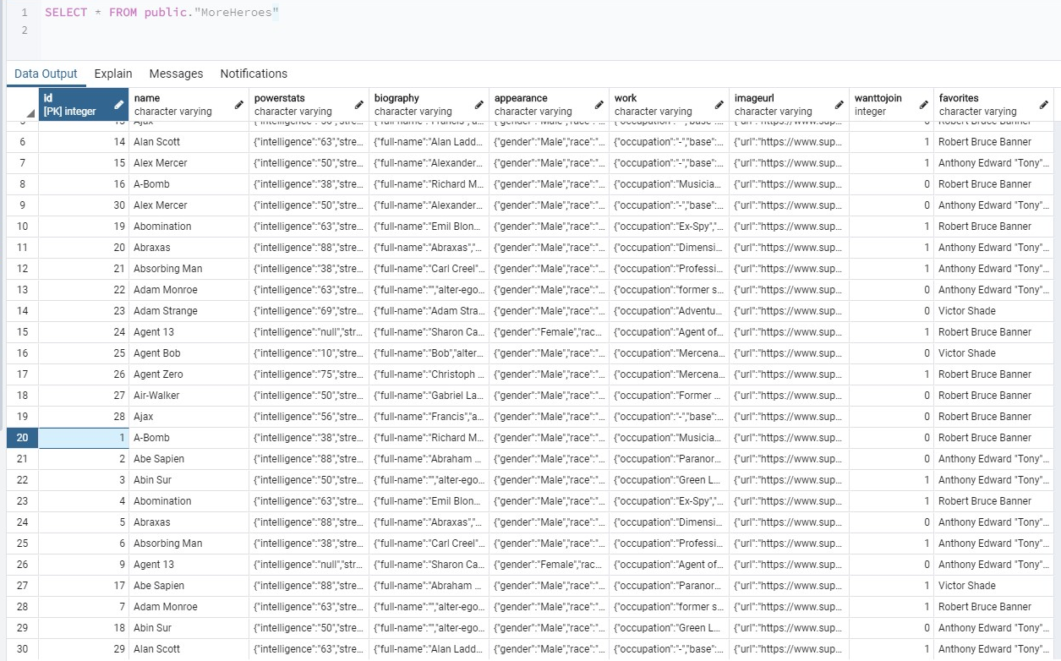

* 1. Create an association between the two tables for who is interested in joining the Avengers.

a. Query:

SELECT moreheroes.name,avenger.name as Avengers

FROM moreheroes

JOIN avenger

ON avenger.name = moreheroes.favorites

WHERE wanttojoin = 1;

b. Columns: 2

c. Expected row count: 7

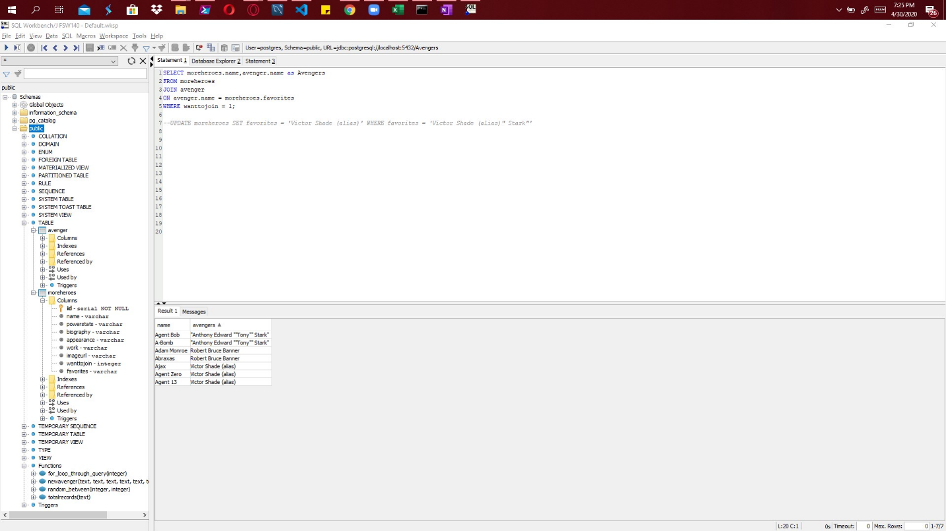

* 1. Show your association and create a new table for that association.

a. Query:

SELECT moreheroes.name as HeroName,avenger.name as Avenger

FROM moreheroes

JOIN avenger

ON avenger.name = moreheroes.favorites

WHERE wanttojoin = 1;

CREATE TABLE association (heroname VARCHAR, avengername VARCHAR);

INSERT INTO association(heroname, avengername)SELECT HeroName, Avenger FROM (SELECT moreheroes.name as HeroName,avenger.name as Avenger

FROM moreheroes

JOIN avenger

ON avenger.name = moreheroes.favorites

WHERE wanttojoin = 1

)t;

b. Columns:  2

c. Expected row count: 7

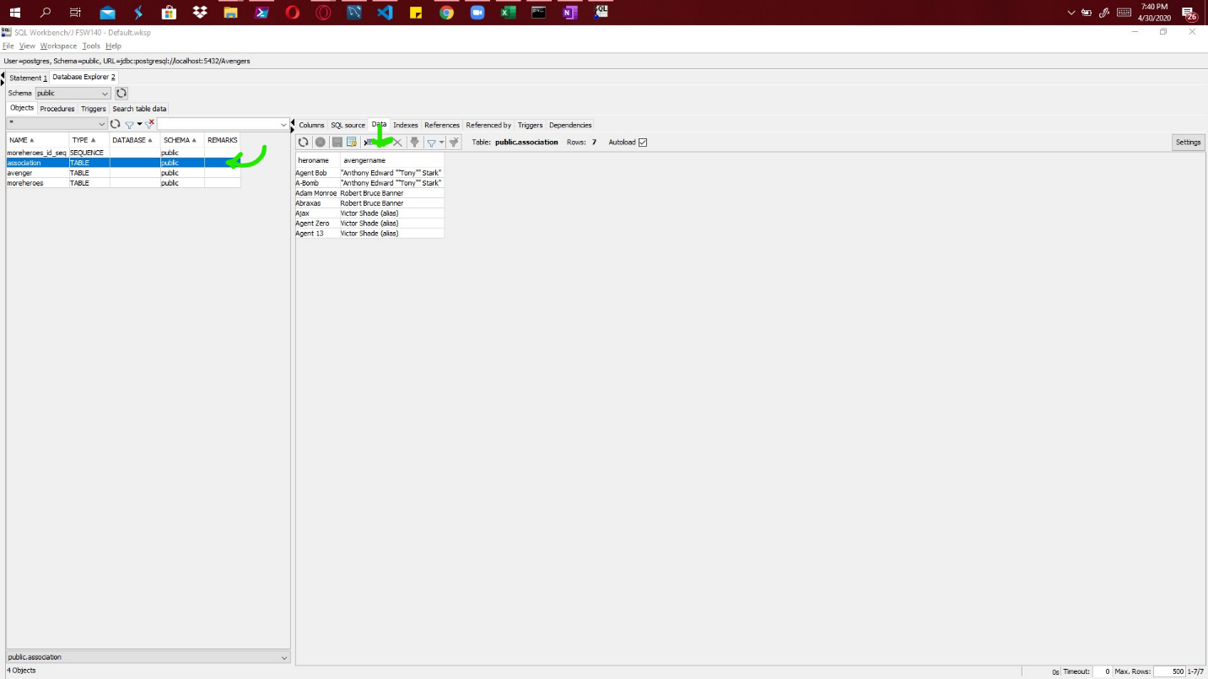

* 1. List all Avengers who have more than 1000 appearances in alphabetic order.

a. Query: SELECT name, TO_NUMBER( appearances, '99G999D9S') FROM avengers WHERE appearances != 'Appearances' AND TO_NUMBER(appearances , '99G999D9S') > 1000 ORDER BY name

b. Columns: 2

c. Expected row count: 20

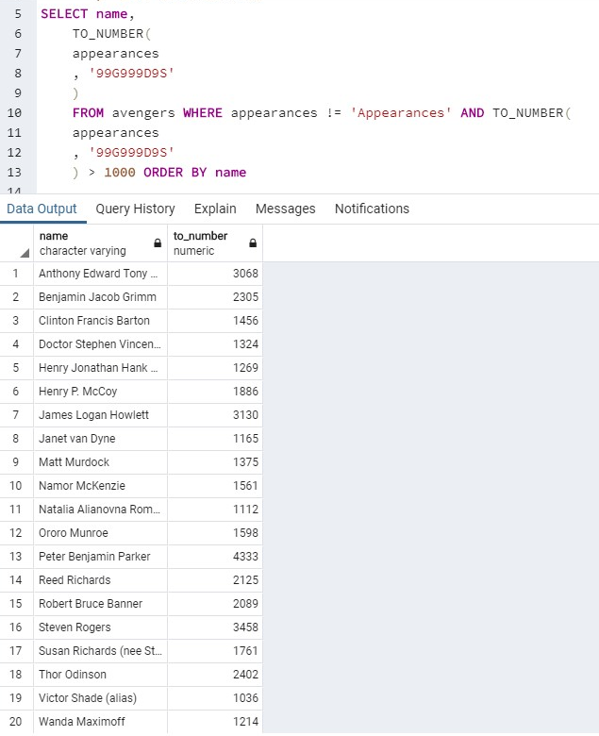

* 1. What Avengers do not have more than 1000 appearances?

a. Query:

SELECT name FROM avengers WHERE appearances != 'Appearances' AND TO_NUMBER(

appearances

, '99G999D9S'

) < 1000

b. Columns: 2

c. Expected row count: 143

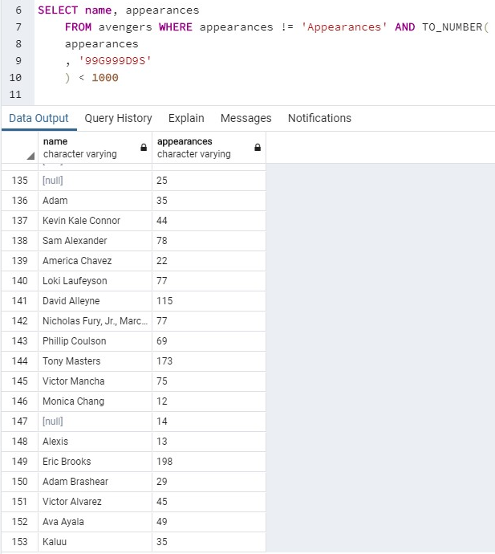

* 1. Not more than 500?

a. Query:

SELECT name, appearances

FROM avengers WHERE appearances != 'Appearances' AND TO_NUMBER(

appearances

, '99G999D9S'

) < 500

b. Columns: 2

c. Expected row count: 130

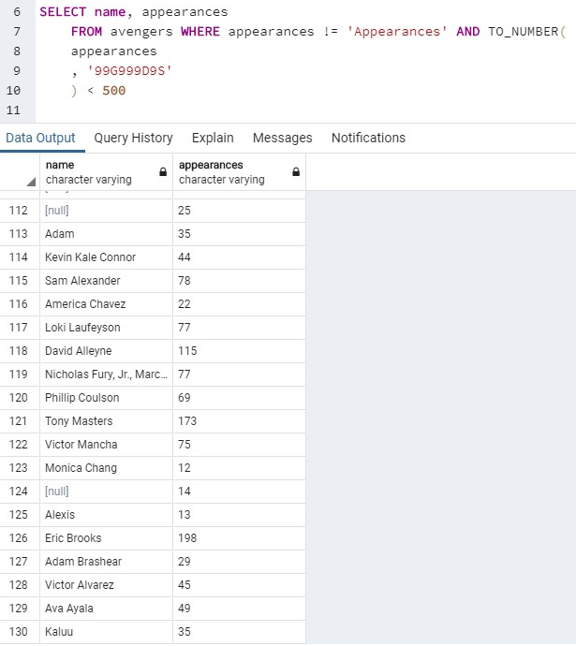

* 1. Not more than 50?

a. Query:

SELECT name, appearances

FROM avengers WHERE appearances != 'Appearances' AND TO_NUMBER(

appearances

, '99G999D9S'

) < 50

b. Columns: 2

c. Expected row count: 40

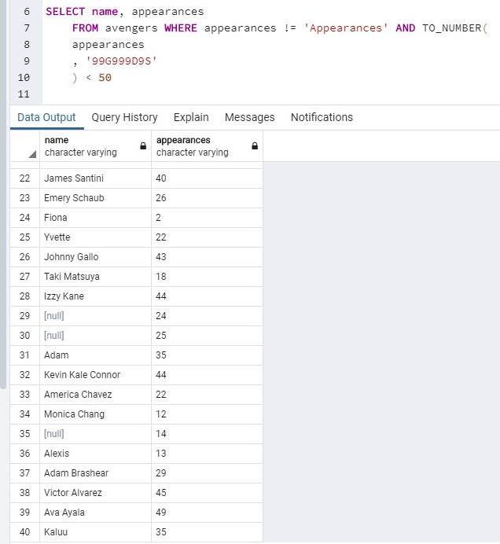

* 1. Not more than 50 and female?

a. Query:

SELECT name, gender, appearances FROM avengers WHERE appearances != 'Appearances' AND TO_NUMBER(appearances , '99G999D9S' ) < 50 AND gender = 'FEMALE'

b. Columns: 3

c. Expected row count: 18

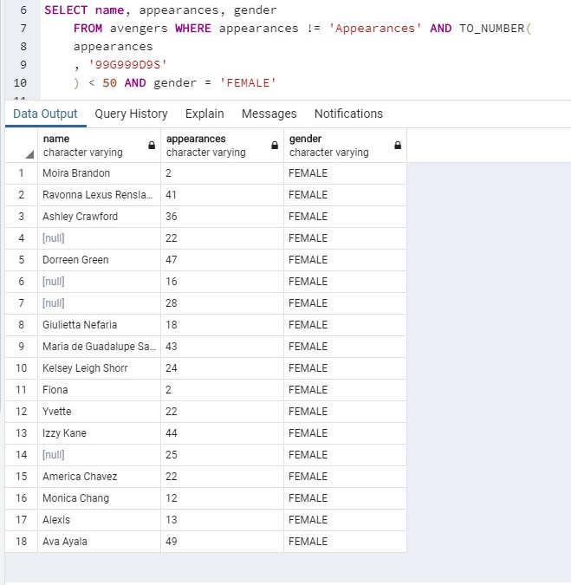

* 1. More than 150, male, and are full members?

a. Query:

SELECT name, gender, appearances, honorary

FROM avengers WHERE appearances != 'Appearances' AND TO_NUMBER( appearances , '99G999D9S' ) > 150 AND gender = 'MALE' AND Honorary ='Full'

b. Columns: 4

c. Expected row count: 52

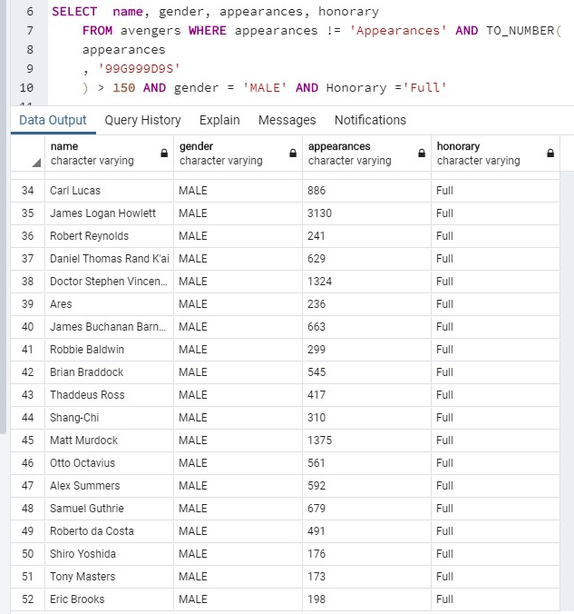

* 1. Write a function that can add a new superhero to the Avengers if they are interested in becoming an Avenger and if their favorite Avenger is Victor Shade.

a. Query:

INSERT INTO public.avengers(

         name,gender

        ,appearances, current,

        probationaryintro, year, yearssincejoining,

        honorary, notes

)

        VALUES ((SELECT name FROM "MoreHeroes" WHERE work LIKE '%Paranormal Investigator%' AND wanttojoin = 1 AND favorites = 'Victor Shade'),

                        (SELECT substring(appearance, 12,4) as gender FROM "MoreHeroes" WHERE work LIKE '%Paranormal Investigator%' AND wanttojoin = 1 AND favorites = 'Victor Shade')

                        ,'0', 'YES','April-20', '2020', '0', 'Academy', 'NA'

                 );

b. Columns: 21

c. Expected row count: 175

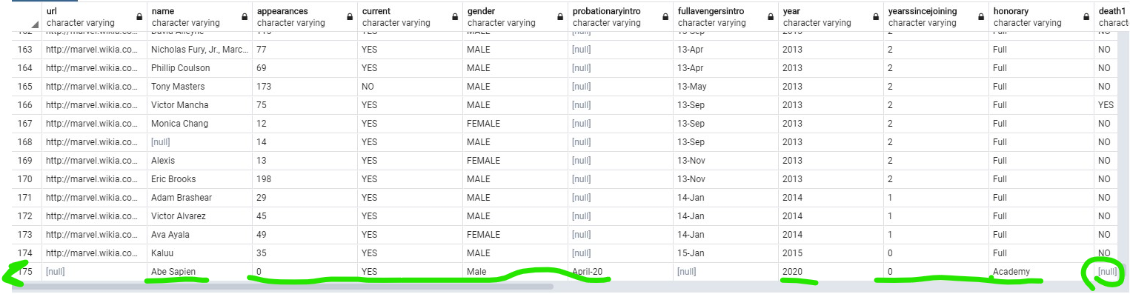

* 1. Write a function that counts the total amount of records(rows/entries) in a given table.

a. Query:

create or replace function

totalRecords( tablename text) returns integer

as

$body$

declare

result integer;

query varchar;

begin

query := 'SELECT count(1) FROM ' || tablename;

execute query into result;

return result;

end;

$body$

language plpgsql;

select totalRecords('avengers');

-- to count all records in the table of avengers for example.

b. Columns: 1

c. Expected row count: 1

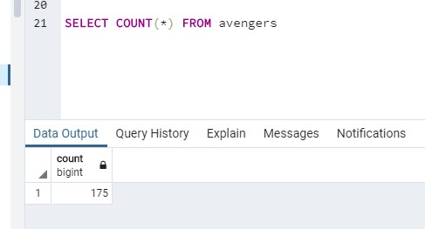

* 1. Call your totalRecords function on the avengers table. What is the output? -oh, upps.

a. Query: select totalRecords('avengers');

b. Columns: 1

c. Expected row count: 1 (screenshot from number 15)

* 1. There is room for 3 new Avengers so invoke your newMember function 3 times to add 3 new members to the Avengers.

a. Query:

create or replace function

newAvenger( name text, gender text,appearances text, current text,

        probationaryintro text, year text, yearssincejoining text,

        honorary text, notes text)

RETURNS bool as $func$

begin

INSERT INTO public.avengers ( name,gender,appearances, current, probationaryintro, year, yearssincejoining,

        honorary, notes) VALUES ( name , gender, appearances, current,

        probationaryintro, year, yearssincejoining,

        honorary, notes );

RETURN FOUND;

END

$func$ LANGUAGE plpgsql;

SELECT newAvenger(

(SELECT name FROM "MoreHeroes" WHERE work LIKE '%Ex-Spy%' AND wanttojoin = 1 AND favorites = 'Victor Shade'),

        (SELECT substring(appearance, 12,4) as gender FROM "MoreHeroes" work LIKE '%Ex-Spy%' AND wanttojoin = 1 AND favorites = 'Victor Shade'),'0',

'YES', 'May-20', '2020', '0', 'Academy','NA');

SELECT newAvenger(

(SELECT name FROM "MoreHeroes" WHEREwork LIKE '%Adventurer%' AND wanttojoin = 1 AND favorites = 'Victor Shade'),

        (SELECT substring(appearance, 12,4) as gender FROM "MoreHeroes" work LIKE '%Adventurer%' AND wanttojoin = 1 AND favorites = 'Victor Shade'),'0',

'YES', 'May-20', '2020', '0', 'Academy','NA');

SELECT newAvenger(

(SELECT name FROM "MoreHeroes" WHERE work LIKE '%Agent of SHIELD%'wanttojoin = 1 AND wanttojoin = 1 AND favorites = 'Victor Shade'),

        (SELECT substring(appearance, 12,4) as gender FROM "MoreHeroes" work LIKE '%Agent of SHIELD%'wanttojoin = 1 AND wanttojoin = 1 AND favorites = 'Victor Shade'),'0',

'YES', 'May-20', '2020', '0', 'Academy','NA');

b. Columns: 21

c. Expected row count: 3 -accidentally deleted ALL rows at the last moment.

* 1. Show that the addition of new members was successful.



a. Query: the function returns every time the insert is successful

b. Columns: 21

c. Expected row count: 3

* 1. Remove any tables that are not the original avengers table and prove that they have been removed.

a. Query: DROP TABLE public.nameoftable

b. Columns: 21

c. Expected row count: 176

